CSC 643 – Big Data & Web Intelligence

db.Team1.find({Ahmad : Sean})

*Project 1*

Table of Contents

***1. Obtaining Data and Import into MongoDB*** 3

***2. Description of Data*** 3

***3. Use Queries to Find the Data*** 5

a) find the total number of artists in database 5

b) find URLs of artists whose name contain the word ***punk*** 5

c) find the most listened artist(s) 5

d) write a mapReduce to compute the top 10 popular artists 7

e) write a mapReduce to find the least user tag 8

f) write a mapReduce to compute the average numer of tags used by each user for all artists 8

***4. Connect MongoDB using Java, write and execute all above queries*** 11

a) find the total number of artists in database 11

b) find URLs of artists whose name contain the word ***punk*** 11

c) find the most listened artist 12

d) find the top 10 artists 13

e) write a mapReduce to find the least user tag 13

f) write a mapReduce to compute the average numer of tags used by each user for all artists 14

Appendix: 15

1- Java Source: 15

2- Java Output: 21

# ***1. Obtaining Data and Import into MongoDB***

* Download data Last.FM_dataset as .dat file type
* Two ways to import data .dat into MongoDB

1. import directly by using statement:

**mongoimort -d FMDB -c Artists --file artists.dat --headerline --type tsv**

1. convert data from *.*dat to *.*csv using Excel, import data .csv into MongoDB by using statement:

**mongoimport -d FMDB -c Artists --file artists.csv --headerline --type csv**

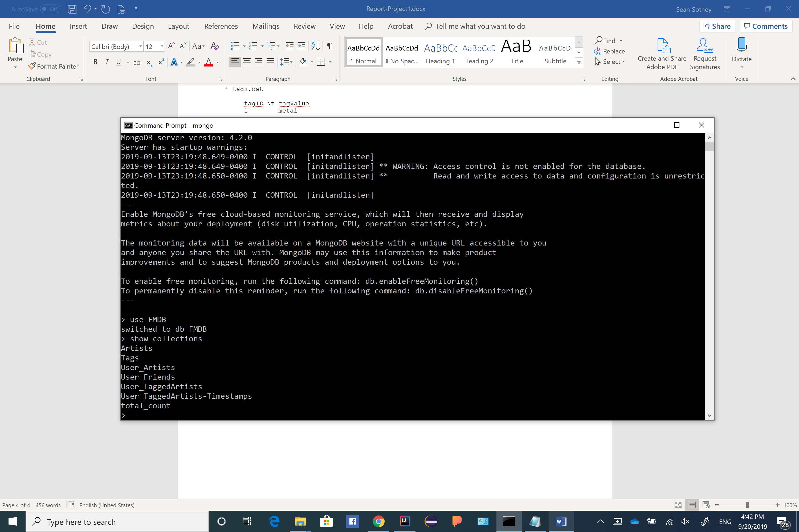**Note\*\*\*** FMDB is database_name, Artists is collection_name, artists.dat is file_name,

type csv/ type tsv is file_type

***To check all imported data, do: **use FMDB** 🡪 **show collections**

# ***2. Description of Data***

-----------

Description

-----------

This dataset contains social networking, tagging, and music artist listening information

from a set of 2K users from Last.fm online music system.

http://www.last.fm

The dataset is released in the framework of the 2nd International Workshop on

Information Heterogeneity and Fusion in Recommender Systems (HetRec 2011)

http://ir.ii.uam.es/hetrec2011

at the 5th ACM Conference on Recommender Systems (RecSys 2011)

<http://recsys.acm.org/2011>

---------------

Data statistics

---------------

1892 users

17632 artists

12717 bi-directional user friend relations, i.e. 25434 (user_i, user_j) pairs

avg. 13.443 friend relations per user

92834 user-listened artist relations, i.e. tuples [user, artist, listeningCount]

avg. 49.067 artists most listened by each user

avg. 5.265 users who listened each artist

11946 tags

186479 tag assignments (tas), i.e. tuples [user, tag, artist]

avg. 98.562 tas per user

avg. 14.891 tas per artist

avg. 18.930 distinct tags used by each user

avg. 8.764 distinct tags used for each artist

-----

Files

-----

* artists.dat

This file contains information about music artists listened and tagged by the users.

* tags.dat

This file contains the set of tags available in the dataset.

* user_artists.dat

This file contains the artists listened by each user.

It also provides a listening count for each [user, artist] pair.

* user_taggedartists.dat - user_taggedartists-timestamps.dat

These files contain the tag assignments of artists provided by each particular user.

They also contain the timestamps when the tag assignments were done.

* user_friends.dat

These files contain the friend relations between users in the database.

-----------

Data format

-----------

The data is formatted one entry per line as follows (tab separated, "\t"):

* artists.dat

id \t name \t url \t pictureURL

Example:

707 Metallica http://www.last.fm/music/Metallica http://userserve-ak.last.fm/serve/252/7560709.jpg

* tags.dat

tagID \t tagValue

1 metal

* user_artists.dat

userID \t artistID \t weight

2 51 13883

* user_taggedartists.dat

userID \t artistID \t tagID \t day \t month \t year

2 52 13 1 4 2009

* user_taggedartists-timestamps.dat

userID \t artistID \t tagID \t timestamp

2 52 13 1238536800000

* user_friends.dat

userID \t friendID

2 275

# ***3. Use Queries to Find the Data***

## a) find the total number of artists in database

using statement: **db.Artists.count( )** 🡪 output: **17632**

## b) find URLs of artists whose name contain the word ***punk***

using statement: **db.Artists.find({url:/punk/i})** / with count: **db.Artists.find({url:/punk/i}).count( )**

🡪 output: show all the Artists with the word ***punk***case insensitive, and total number is ***7***

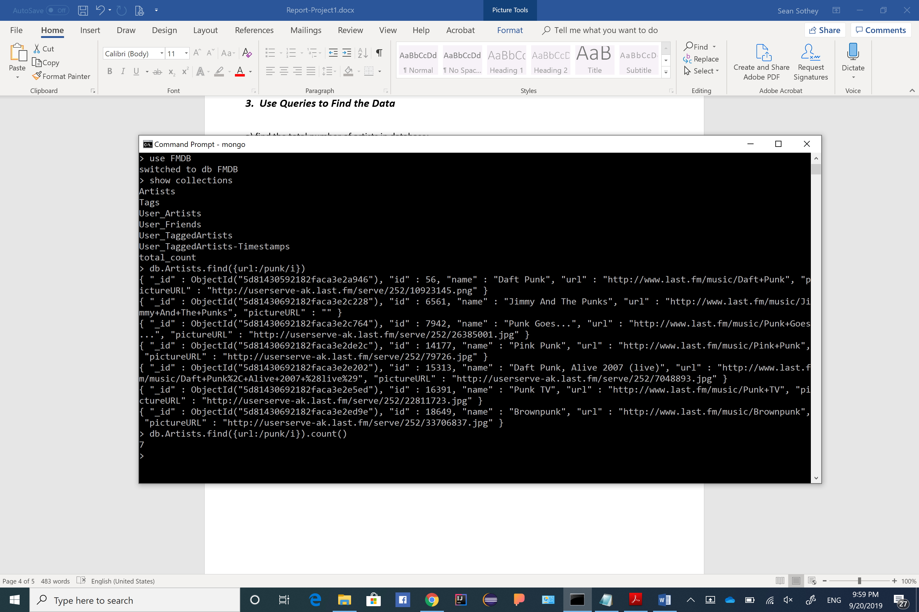

## c) find the most listened artist(s)

First, you should know which collection you should use to find the result sets.

Based on section ***2. Description of Data***:

* user_artists.dat

This file contains the artists listened by each user.

It also provides a listening count for each [user, artist] pair.

Therefore, **User_Artists** collection shall be used.

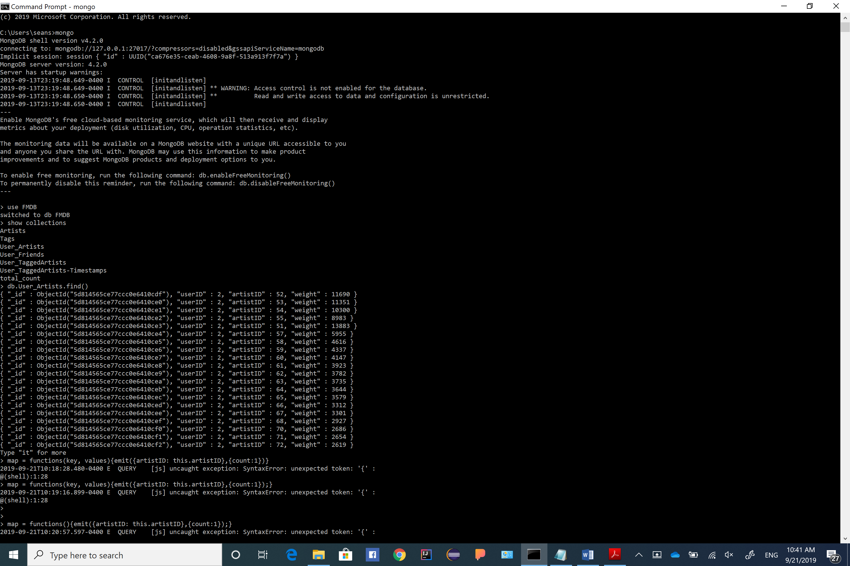Now let’s observe what’s inside the **User_Artists** collection data, using: **db.User_Artists.find( )**

* output:

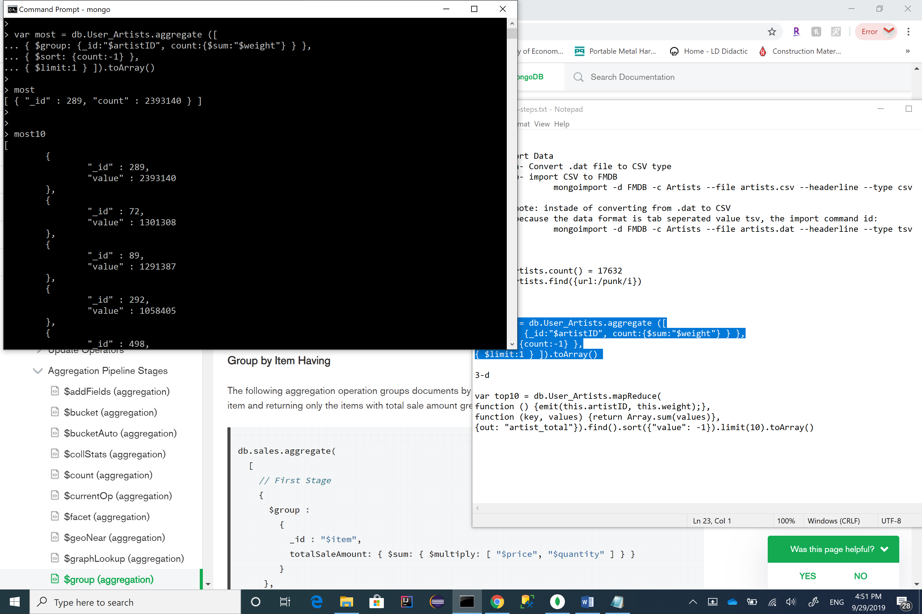We can see the attribute **artistID** projects each artist, **weight** is the number of listens, therefore, we use them in the statement, we do:

* output:

*Ref:*[*https://docs.mongodb.com/manual/reference/operator/aggregation/group/*](https://docs.mongodb.com/manual/reference/operator/aggregation/group/)

This statement perform grouping and counting all the **weight** in the collection **User_Artists**, sorting the count descending and projecting the only first element, and stored in the Array of the variable ***most***, which represent to the most listened artist, obtaining value **2393140**.

To get the artist name, using: **db.Artists.find({id:289},{name:1})**

* 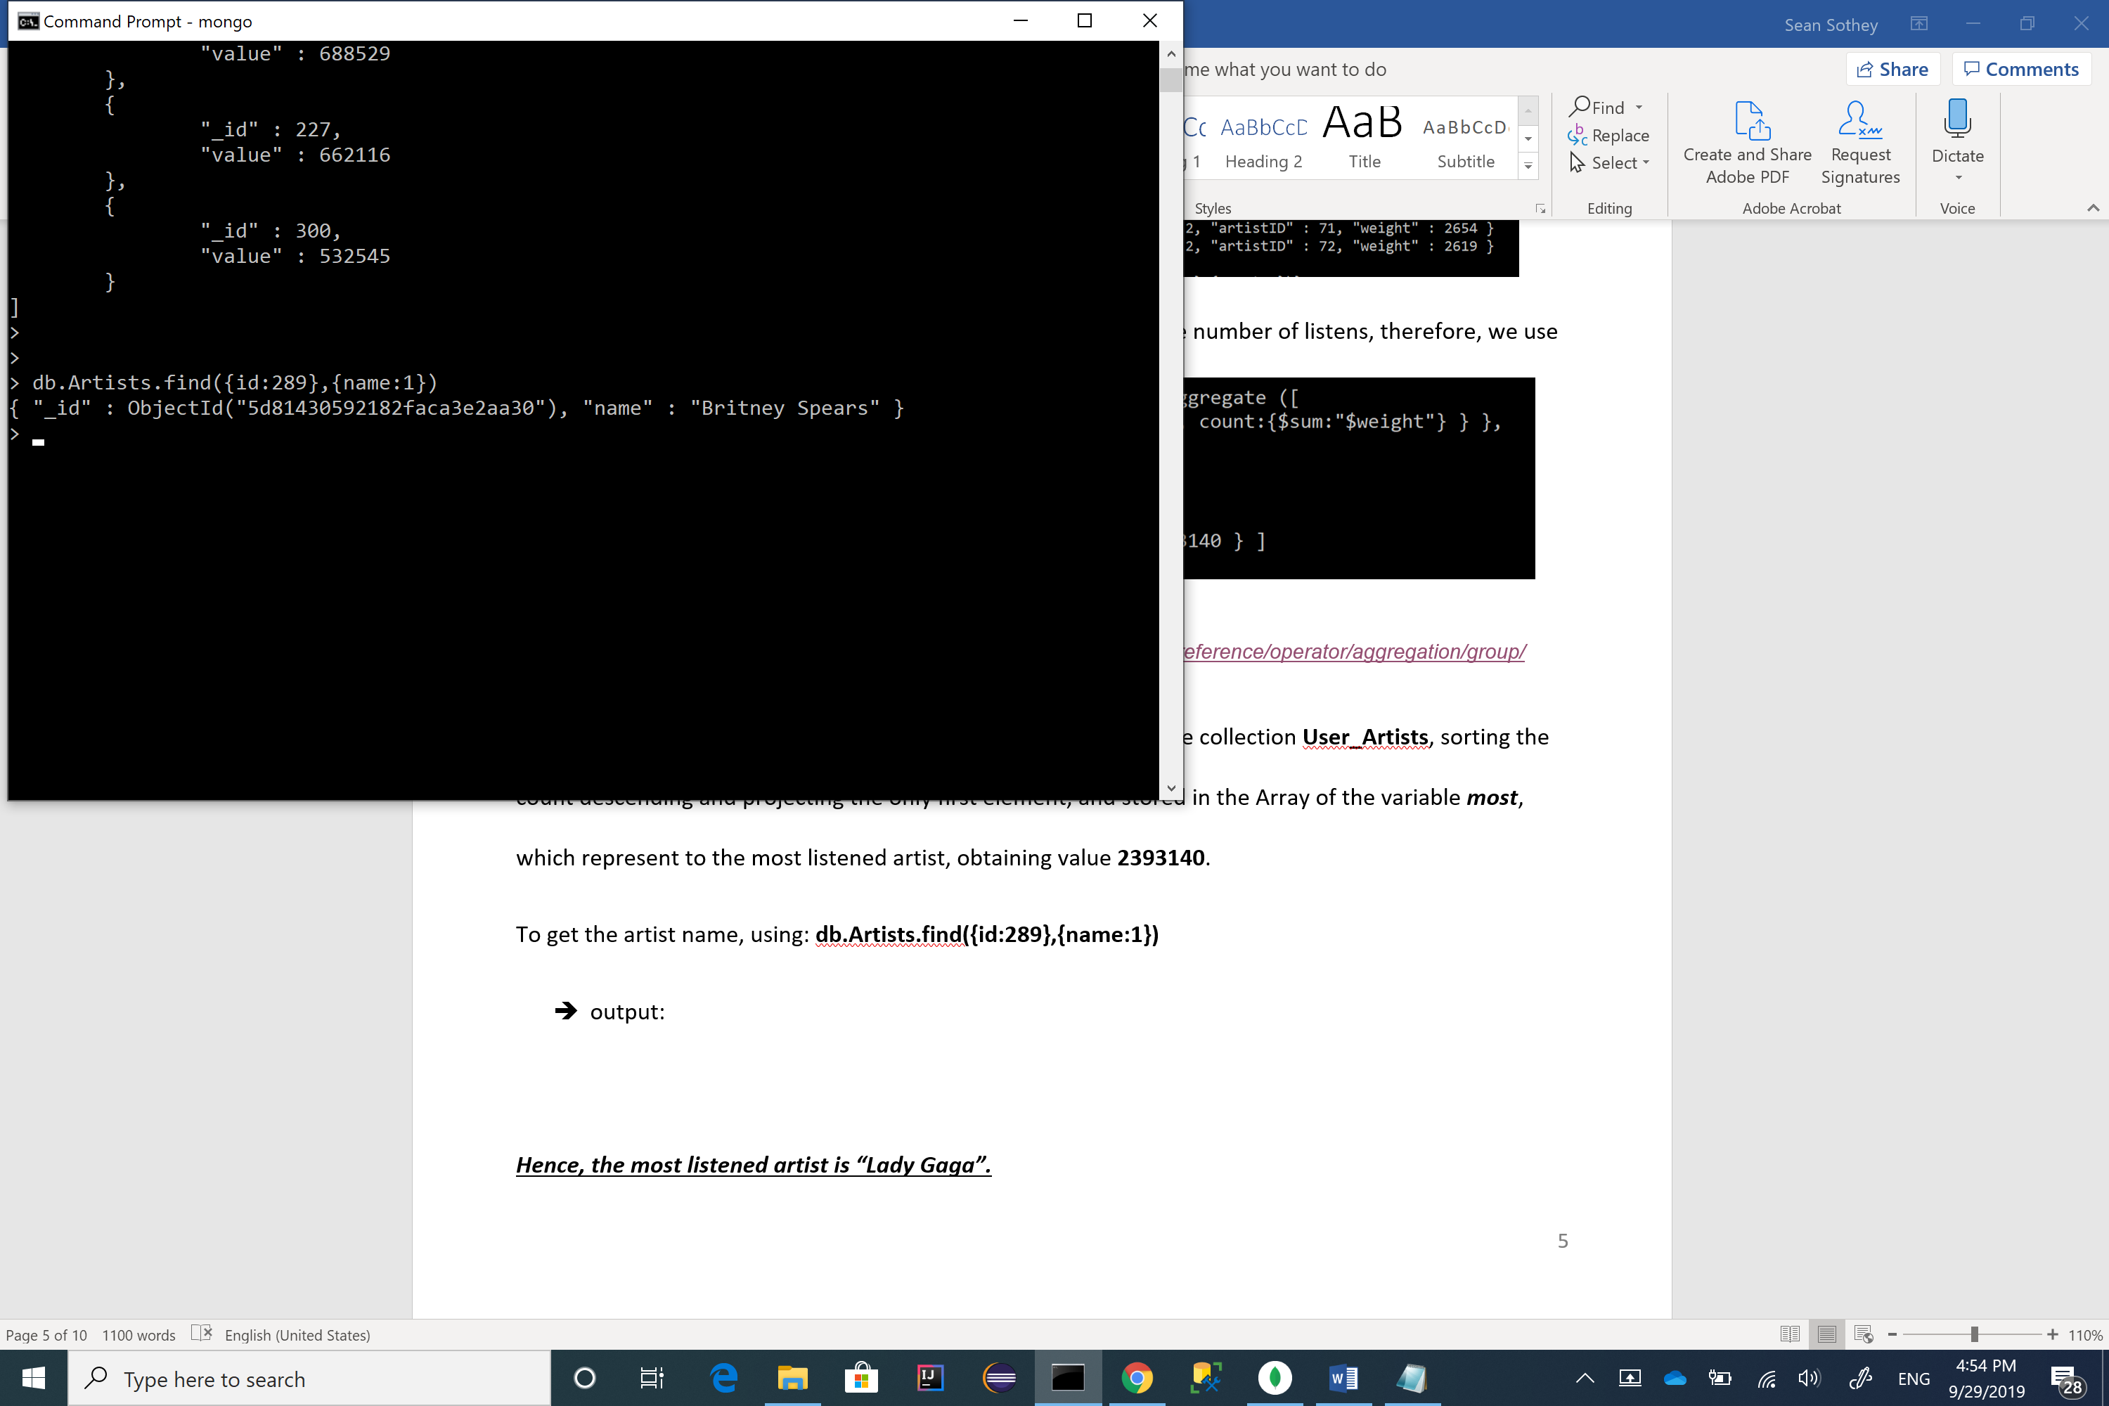output:

***Hence, the most listened artist is “Britney Spears”.***

## d) write a mapReduce to compute the top 10 popular artists

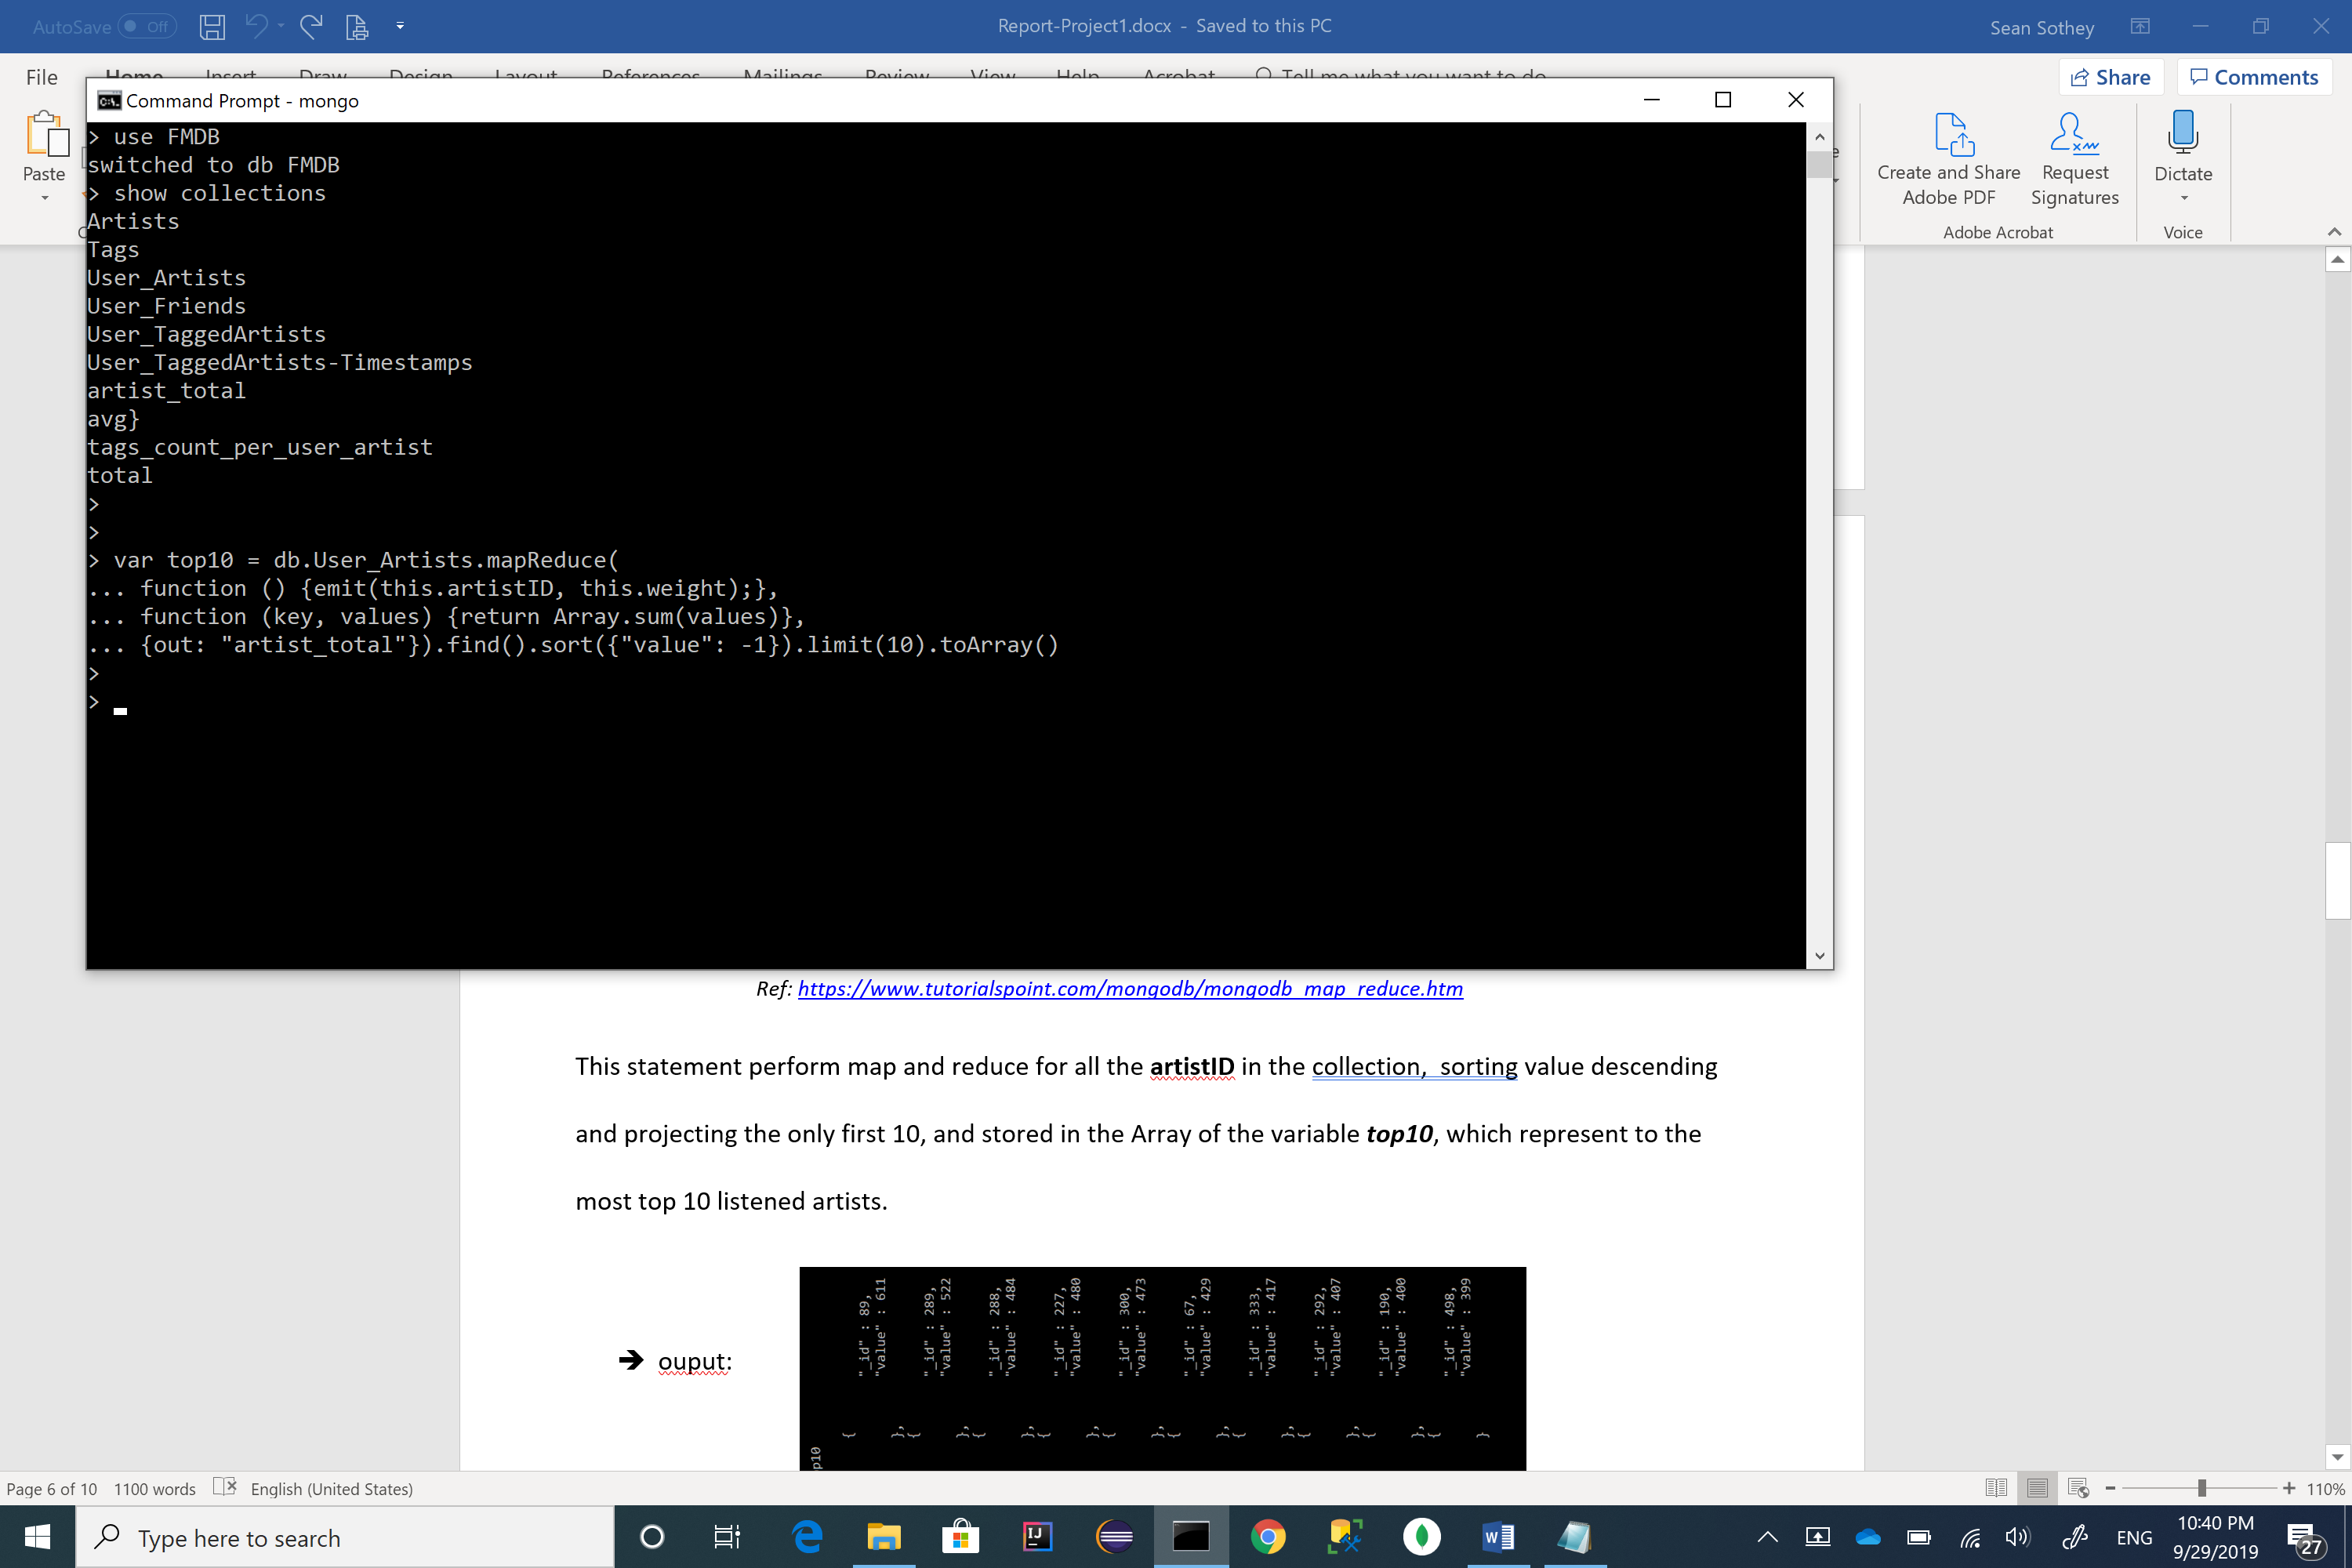Again, we use same collection **User_Artists** with attribute **artistID** and **weight** to find the result sets.

we do:

*Ref:* [*https://www.tutorialspoint.com/mongodb/mongodb_map_reduce.htm*](https://www.tutorialspoint.com/mongodb/mongodb_map_reduce.htm)

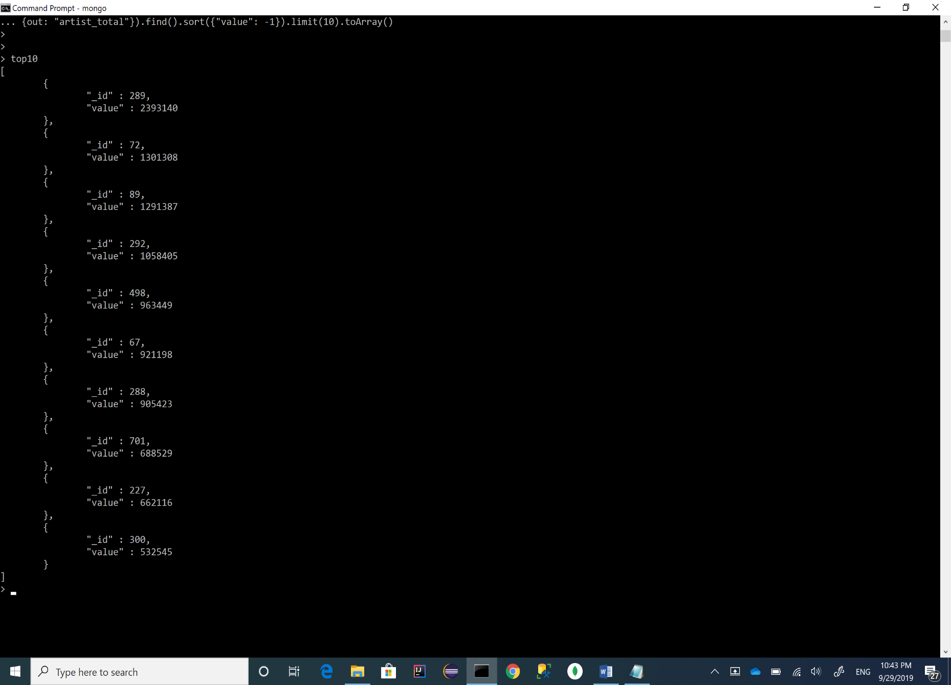This statement perform map and reduce for all the **artistID** in the collection, sorting value descending and projecting the only first 10, and stored in the Array of the variable ***top10***, which represent to the most top 10 listened artists.

* ouput:

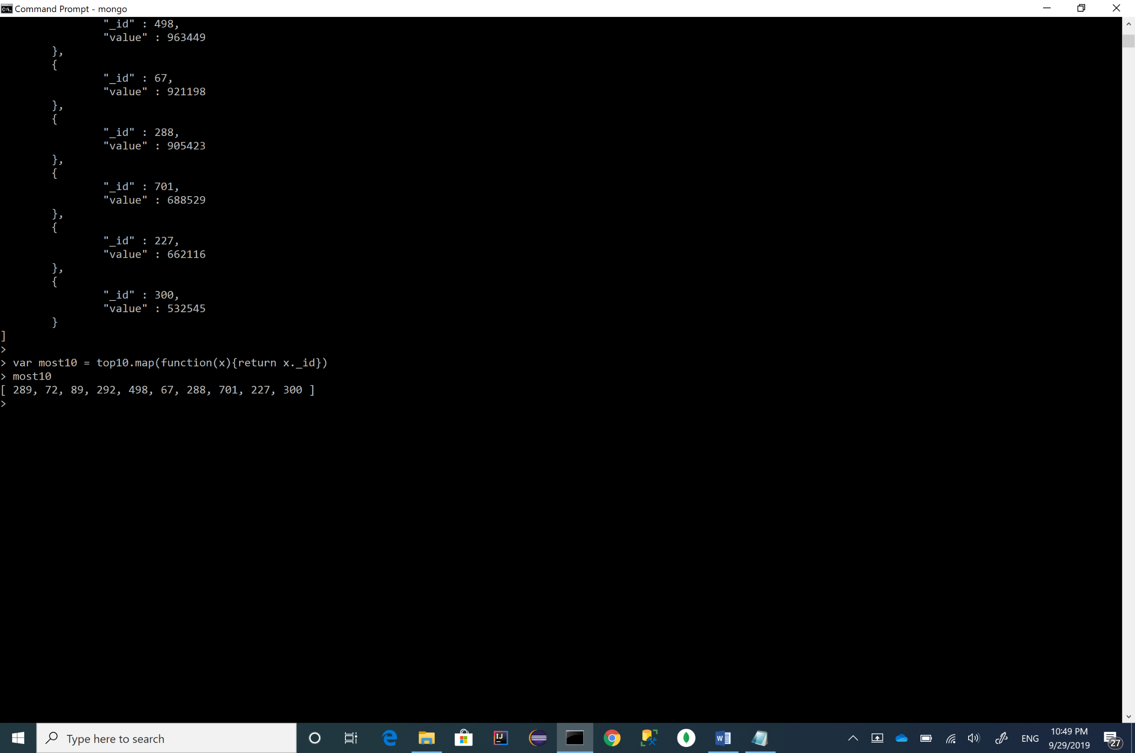To get the top 10 artist names, we can do one by one using the same statement in 3-C. Alternatively, creating an Array that obtain all 10 **_id,** then project the 10 artist names once together.

Creating an Array of 10 **_id**, we do:

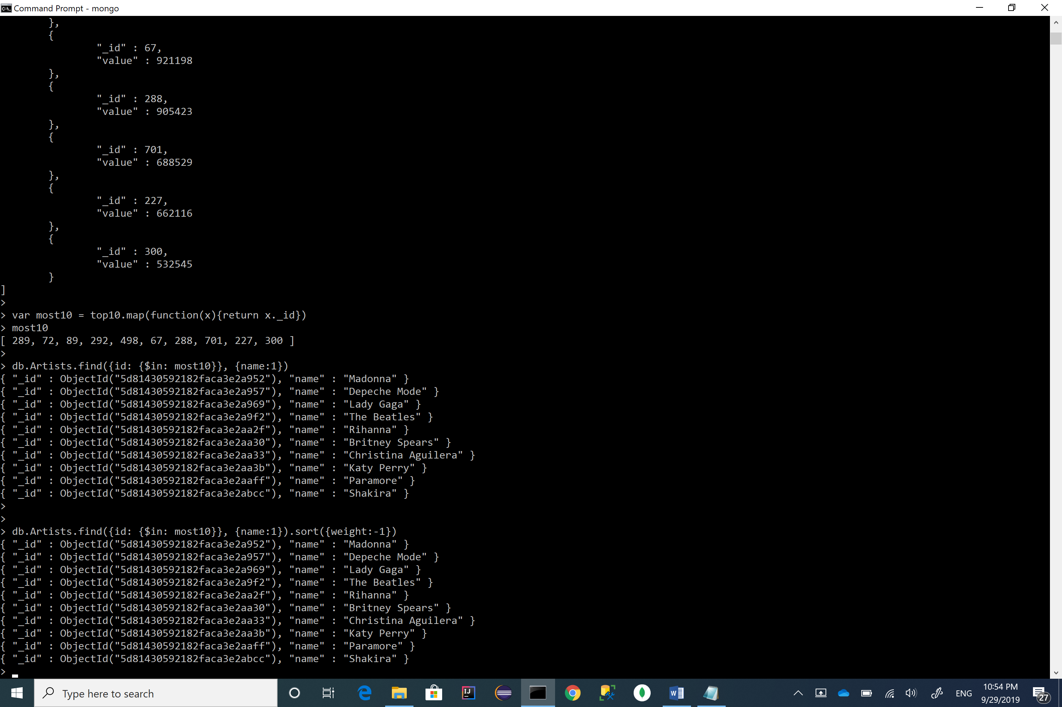Projecting the top 10 artist names, using: **db.Artists.find({id:{$in:most10}},{name:1})**

* output:

## e) write a mapReduce to find the least user tag

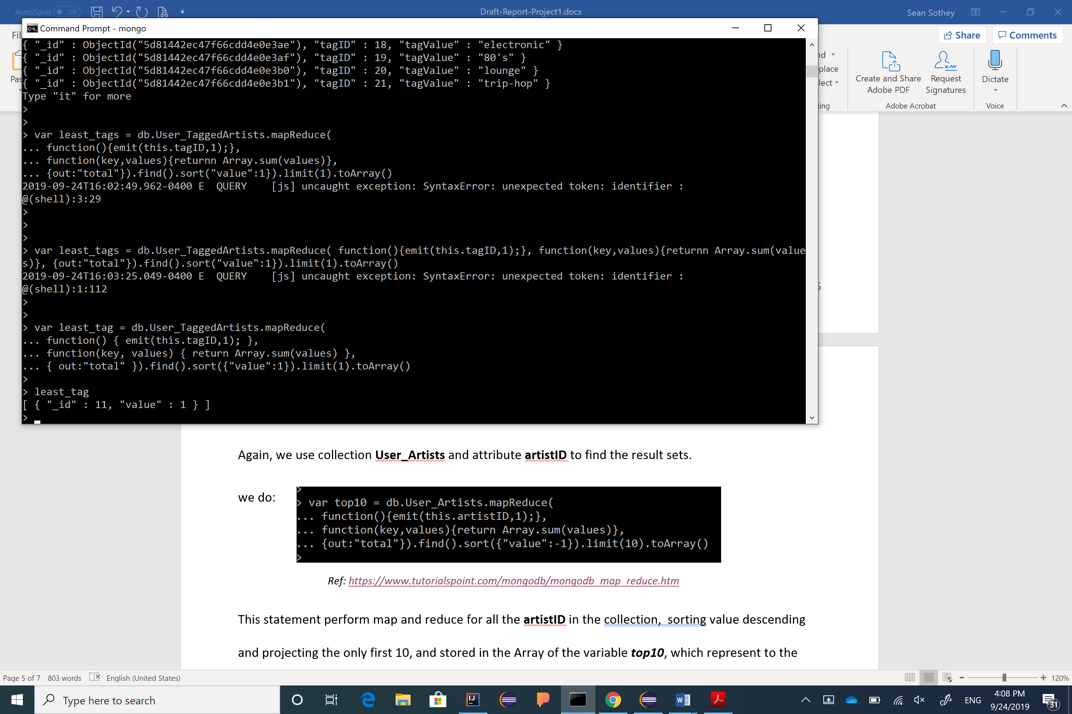Following the same procedure as C & D, this time we use **tagID** to write mapReduce.

we do:

* output:

To get the artist name, using: **db.Artists.find({id:least_tag [0]._id},{name:1})**

* 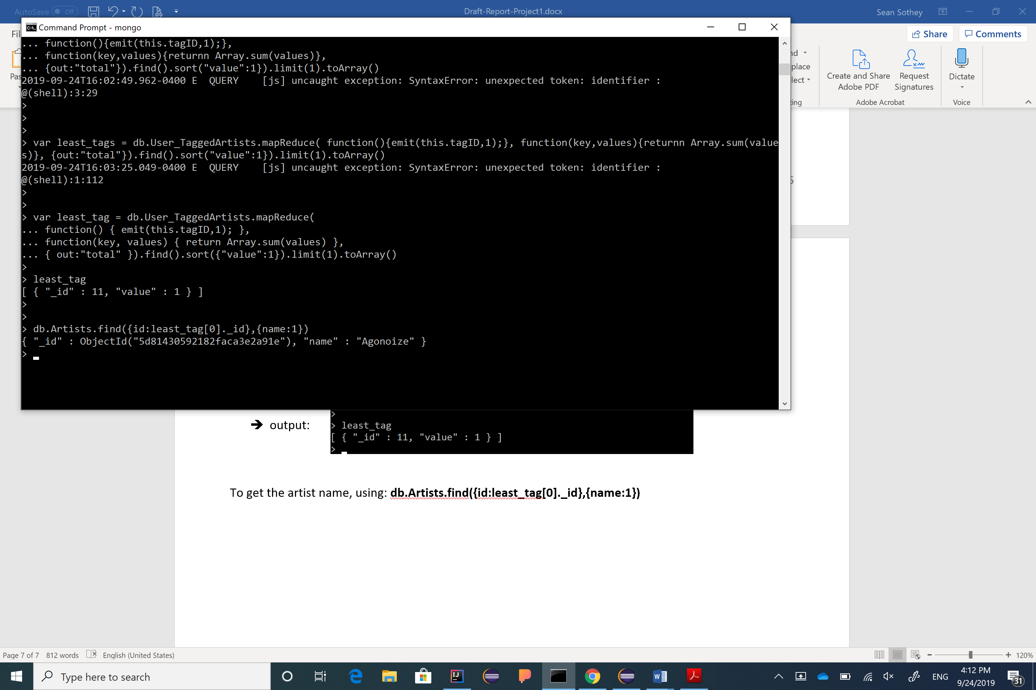output:

***Hence, the least user tagged artist is “Agonoize”.***

## f) write a mapReduce to compute the average numer of tags used by each user for all artists

Based on section ***2. Description of Data***:

* tags.dat

This file contains the set of tags available in the dataset.

* user_artists.dat

This file contains the artists listened by each user.

It also provides a listening count for each [user, artist] pair.

* user_taggedartists.dat - user_taggedartists-timestamps.dat

These files contain the tag assignments of artists provided by each particular user.

They also contain the timestamps when the tag assignments were done.

Therefore, **Tags**, **User_Artists** , and **User_TaggedArtists** collection shall be used, as well their attributes, to write map reduce functions.

The average shall be expressed as : avg = tags_sum / tags_count

Similar to the above solution, we write the mapRedce function 2 layers as below:

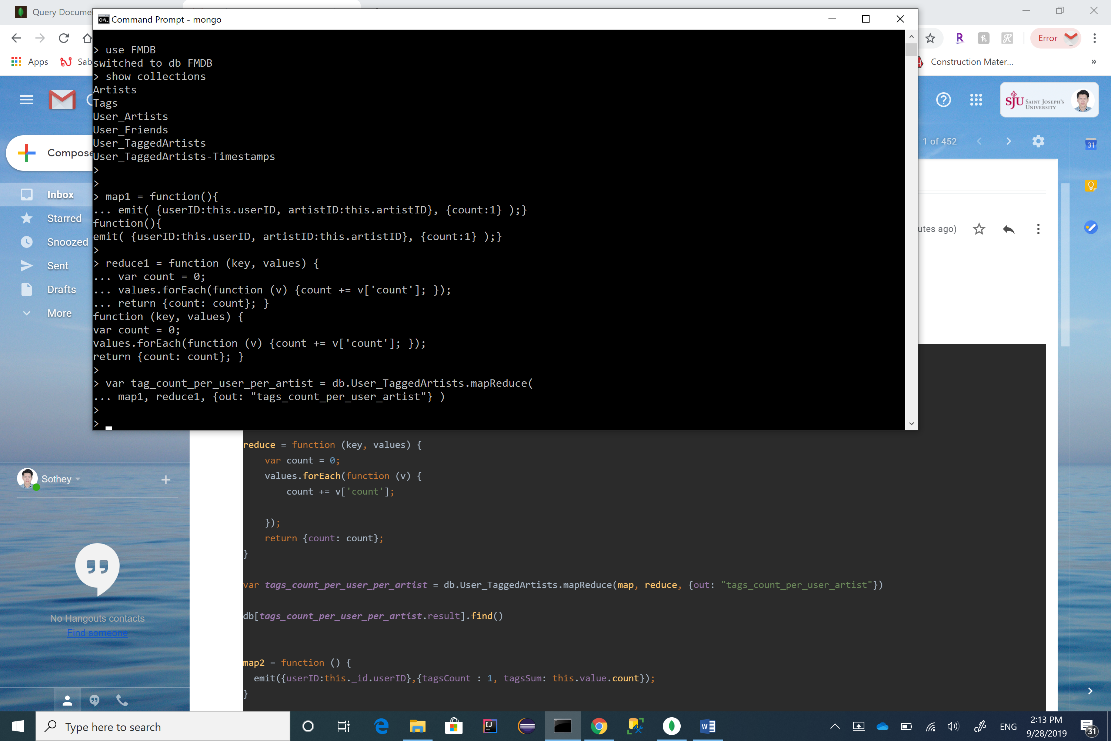First layer, we do:

To show the result sets of each count, using: **db[tag_count_per_user_per_artist.result].find( )**

* 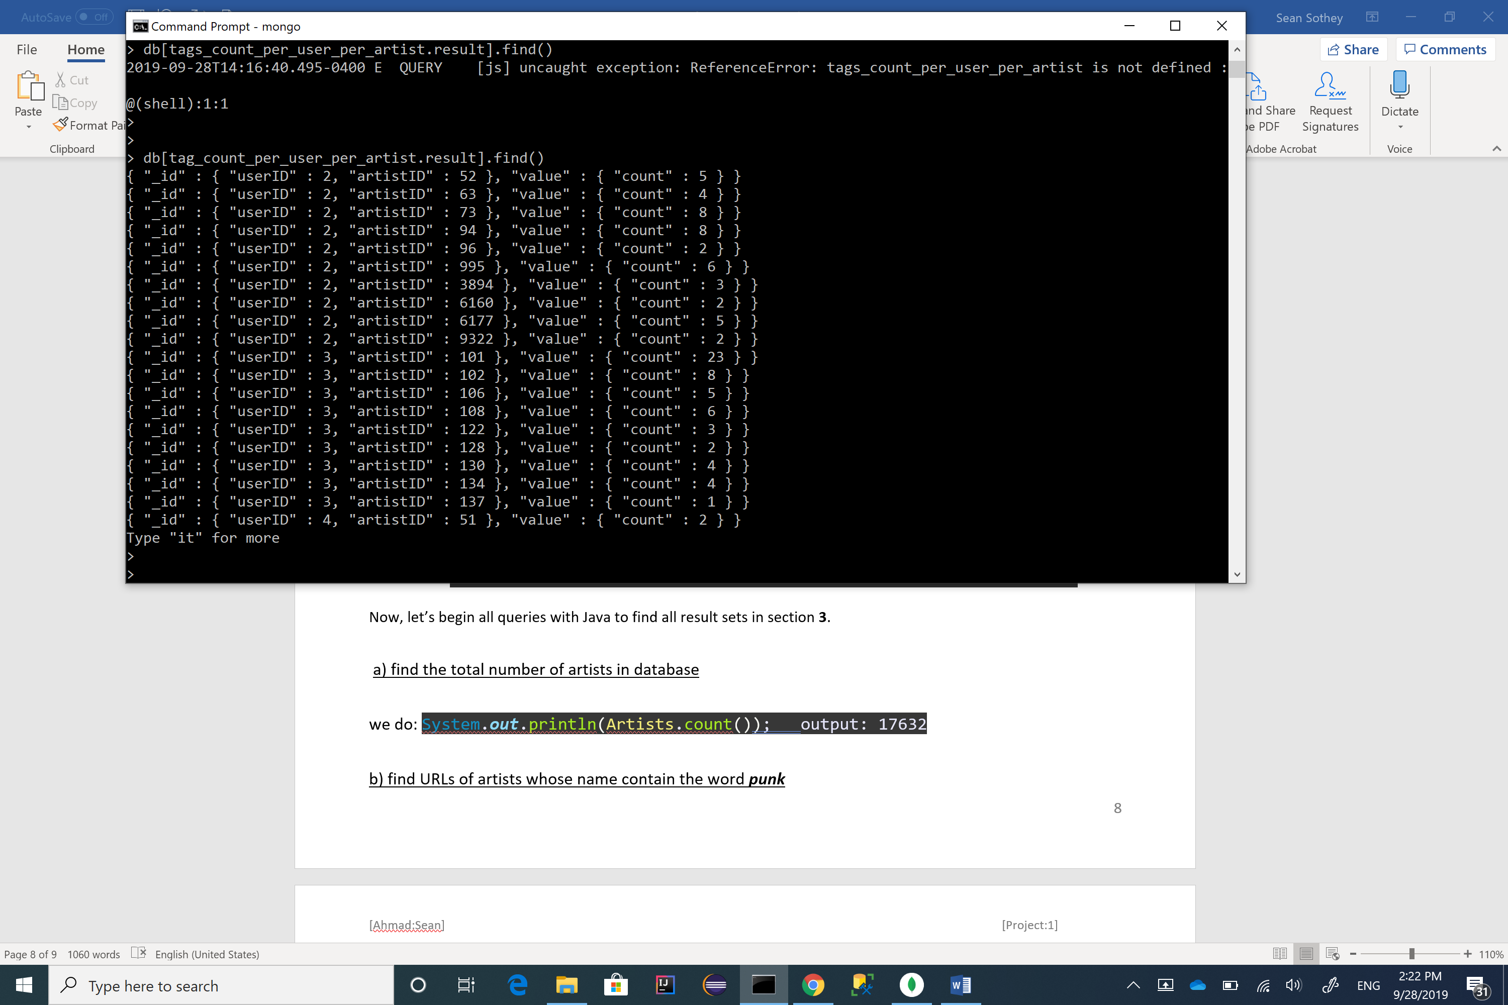output:

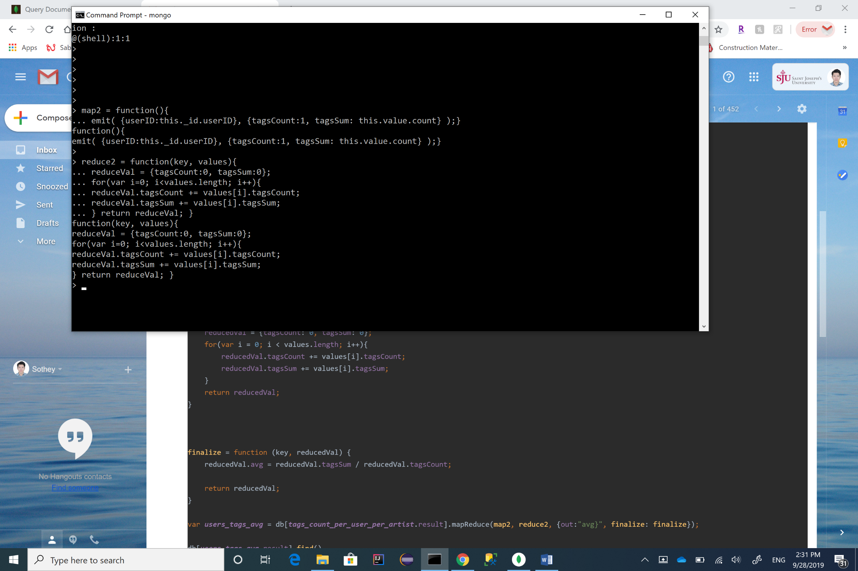Second layer,

we do:

Create a function to aggregate the average, we do:

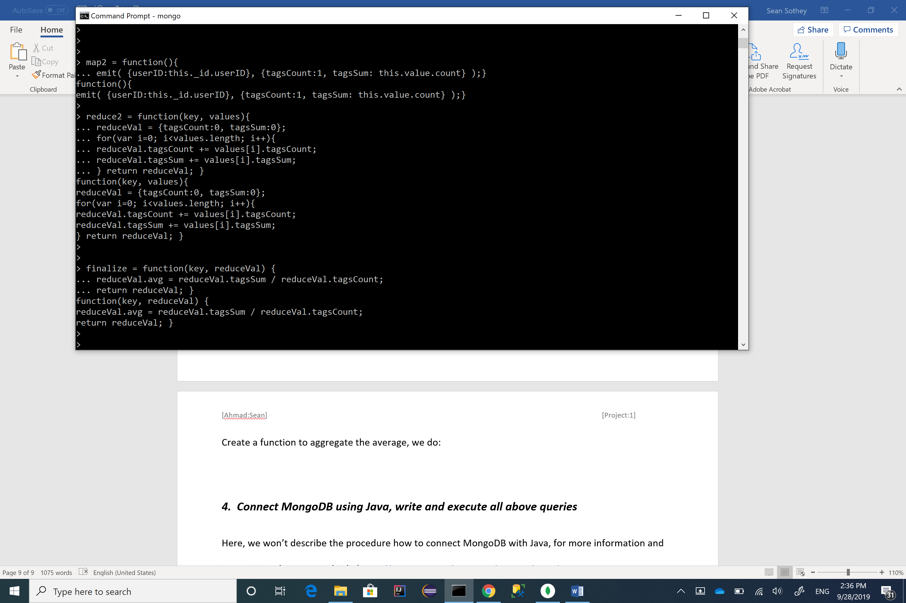

Applying all functions together to get the result of average, we do:

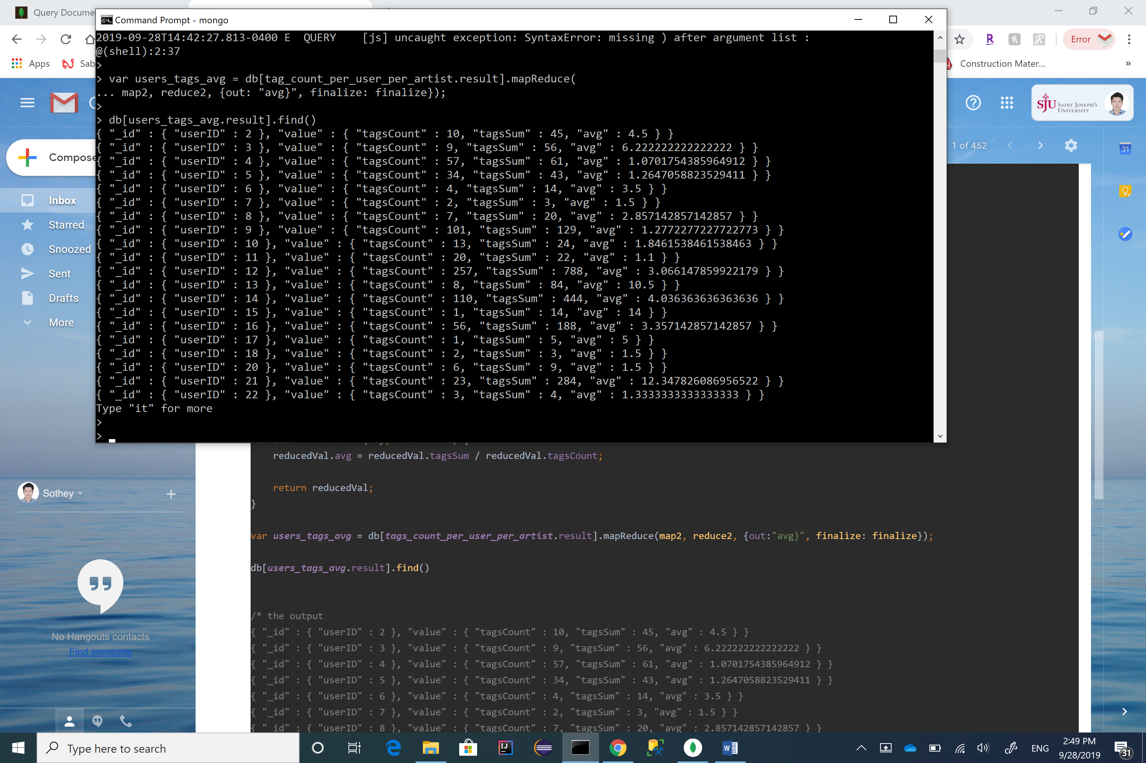

*Ref:* [*https://docs.mongodb.com/manual/reference/method/db.collection.mapReduce/*](https://docs.mongodb.com/manual/reference/method/db.collection.mapReduce/)

# ***4. Connect MongoDB using Java, write and execute all above queries***

Here, we won’t describe the procedure how to connect MongoDB with Java, for more information and instruction, please go to this link <http://people.sju.edu/~bforoura/tutorials/nosql/index.htm#interface>

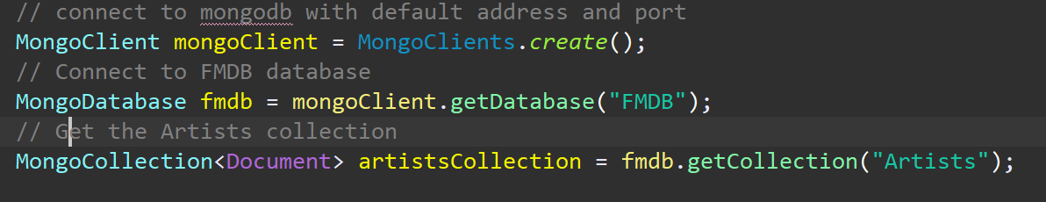To call the database and collections in Java,

Now, let’s begin all queries with Java to find all result sets following section **3**.

## a) find the total number of artists in database



## b) find URLs of artists whose name contain the word ***punk***

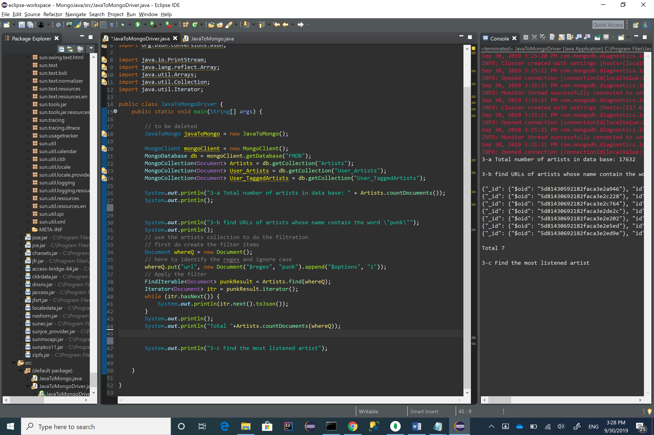

## c) find the most listened artist

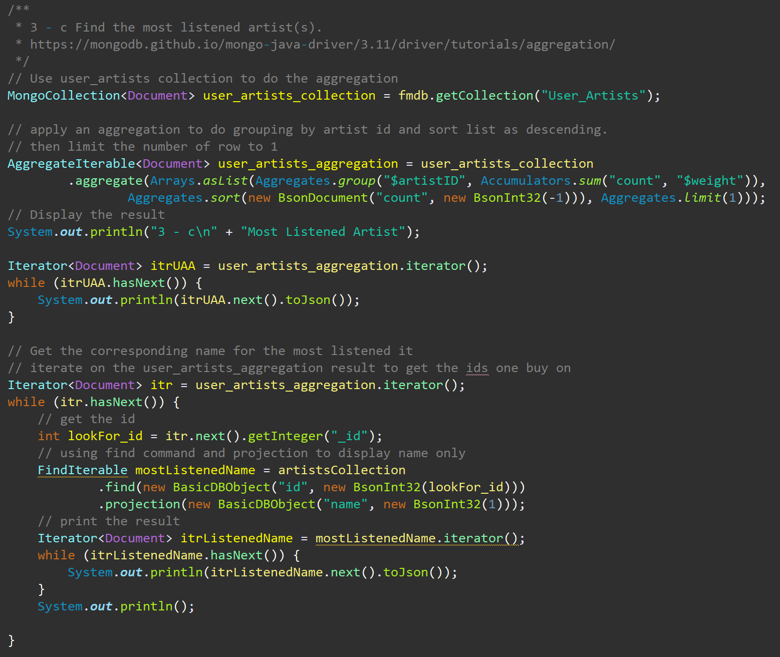

## d) find the top 10 artists

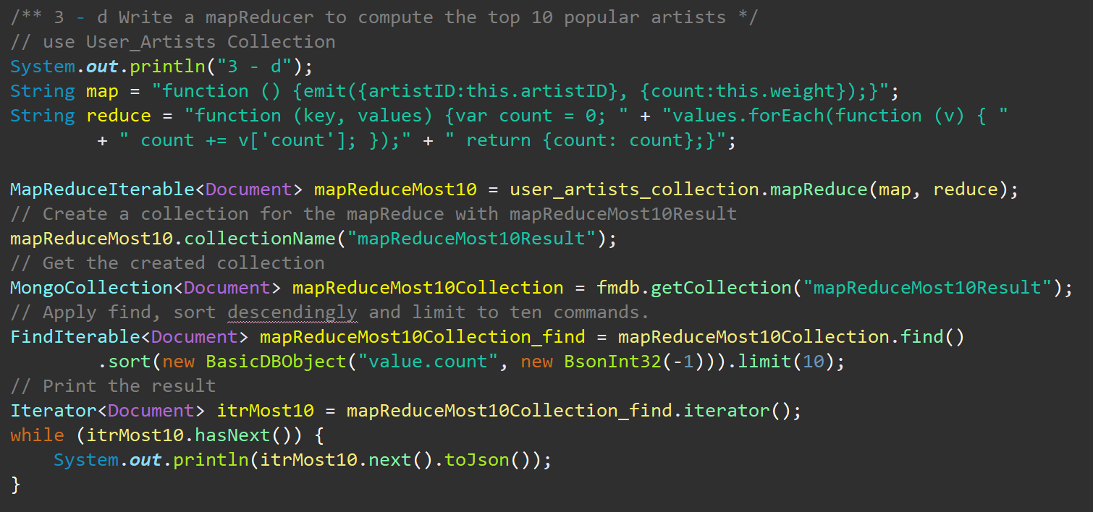

## e) write a mapReduce to find the least user tag

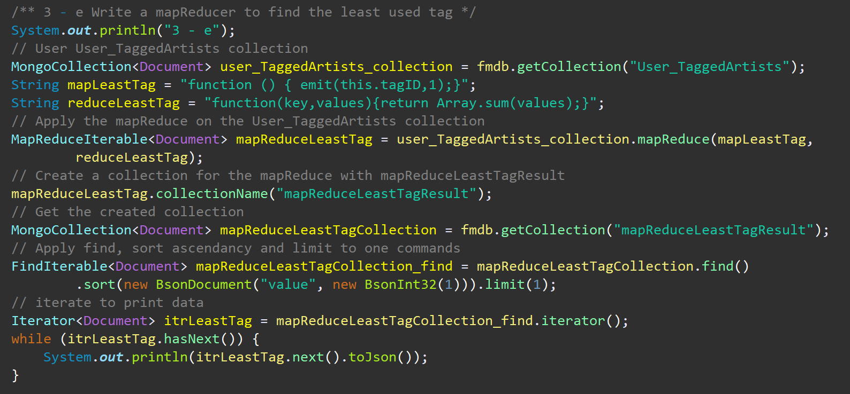

## f) write a mapReduce to compute the average numer of tags used by each user for all artists

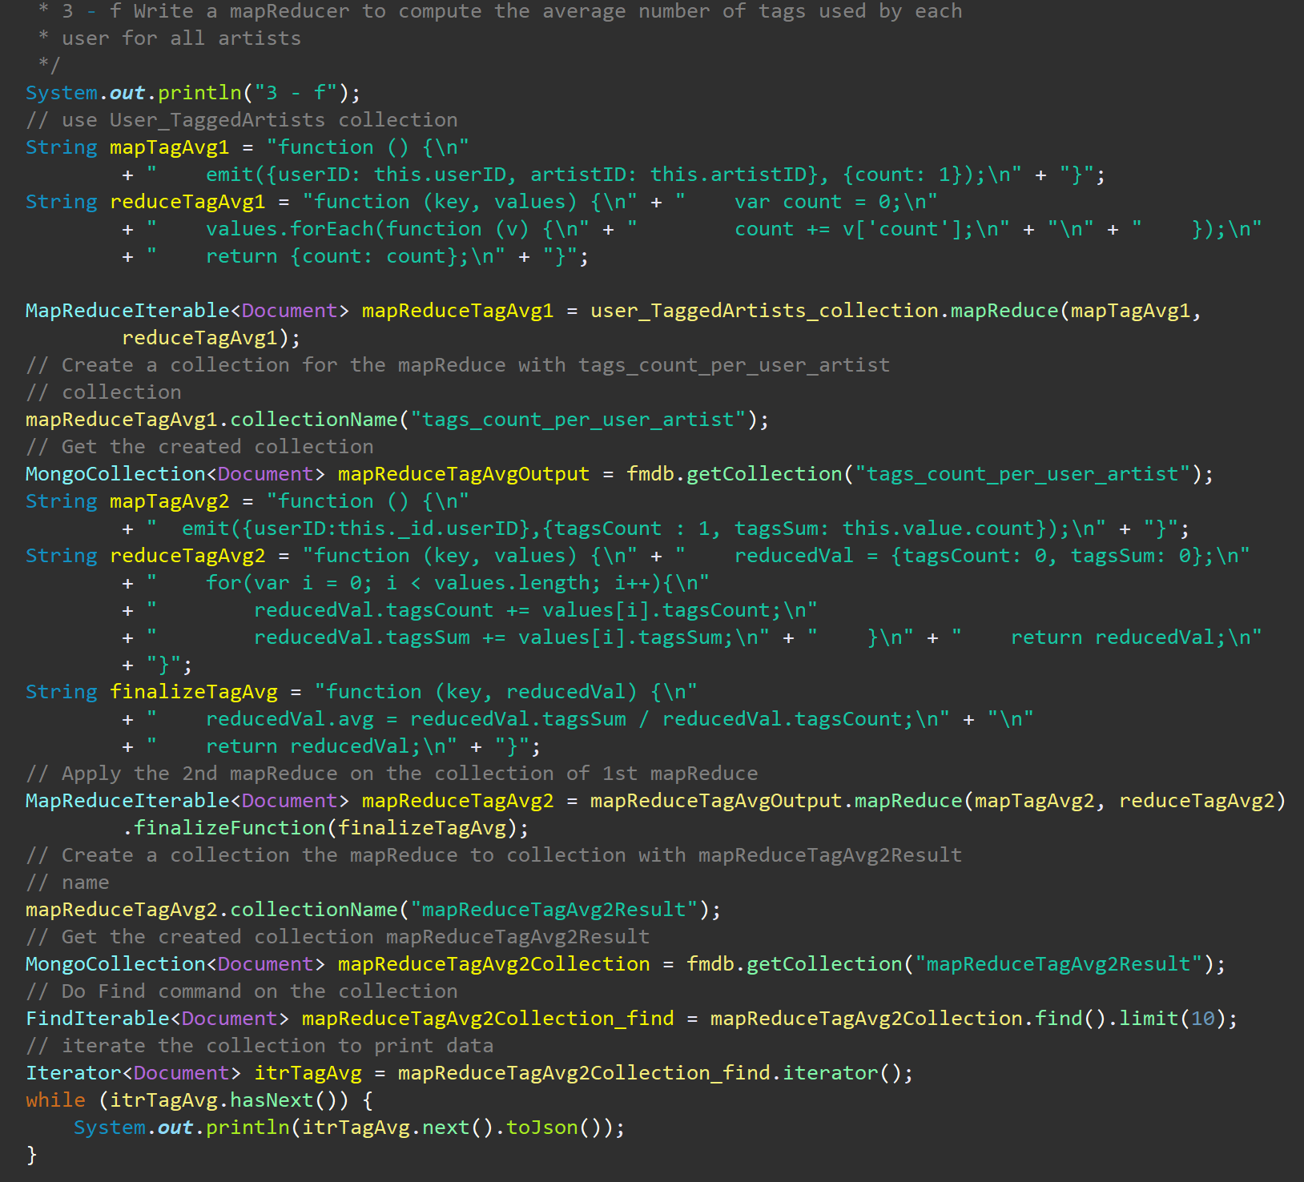

# Appendix:

## 1- Java Source:

import com.mongodb.*;

import com.mongodb.client.*;

import com.mongodb.client.MongoClient;

import com.mongodb.client.model.*;

import org.bson.*;

import java.util.Arrays;

import java.util.Iterator;

public class JavaToMongoDriver {

public static void main(String[] args) {

try {

// connect to mongodb with default address and port

MongoClient mongoClient = MongoClients.create();

// Connect to FMDB database

MongoDatabase fmdb = mongoClient.getDatabase("FMDB");

// FGet the Artists collection

MongoCollection<Document> artistsCollection = fmdb.getCollection("Artists");

/** 3 - a Find the total number of artists in the database */

System.out.println(

"3 - a\n" + "Total number of artists in FMDB: " + artistsCollection.countDocuments() + "\n");

/** 3 - b Find URLs of artists whose names contain the word punk. */

// use the artists collection to do the filtration

// first do create the filter items

Document whereQ = new Document();

// here to identify the regex and ignore case

whereQ.put("url", new Document("$regex", "punk").append("$options", "i"));

// Apply the filter

FindIterable<Document> punkResult = artistsCollection.find(whereQ);

System.out.println("3 - b\n db.Artists.find({url:/punk/i}");

Iterator<Document> itrPunkResult = punkResult.iterator();

while (itrPunkResult.hasNext()) {

System.out.println(itrPunkResult.next().toJson());

}

// Empty Line

System.out.println();

// print the count of the filter

System.out.println("db.Artists.find({url:/punk/i}).count( )");

System.out.println(artistsCollection.countDocuments(whereQ));

// Empty Line

System.out.println();

/**

* 3 - c Find the most listened artist(s).

* https://mongodb.github.io/mongo-java-driver/3.11/driver/tutorials/aggregation/

*/

// Use user_artists collection to do the aggregation

MongoCollection<Document> user_artists_collection = fmdb.getCollection("User_Artists");

// apply an aggregation to do grouping by artist id and sort list as descending.

// then limit the number of row to 1

AggregateIterable<Document> user_artists_aggregation = user_artists_collection

.aggregate(Arrays.asList(Aggregates.group("$artistID", Accumulators.sum("count", "$weight")),

Aggregates.sort(new BsonDocument("count", new BsonInt32(-1))), Aggregates.limit(1)));

// Display the result

System.out.println("3 - c\n" + "Most Listened Artist");

Iterator<Document> itrUAA = user_artists_aggregation.iterator();

while (itrUAA.hasNext()) {

System.out.println(itrUAA.next().toJson());

}

// Get the corresponding name for the most listened it

// iterate on the user_artists_aggregation result to get the ids one buy on

Iterator<Document> itr = user_artists_aggregation.iterator();

while (itr.hasNext()) {

// get the id

int lookFor_id = itr.next().getInteger("_id");

// using find command and projection to display name only

FindIterable mostListenedName = artistsCollection

.find(new BasicDBObject("id", new BsonInt32(lookFor_id)))

.projection(new BasicDBObject("name", new BsonInt32(1)));

// print the result

Iterator<Document> itrListenedName = mostListenedName.iterator();

while (itrListenedName.hasNext()) {

System.out.println(itrListenedName.next().toJson());

}

System.out.println();

}

/** 3 - d Write a mapReducer to compute the top 10 popular artists */

// use User_Artists Collection

System.out.println("3 - d");

String map = "function () {emit({artistID:this.artistID}, {count:this.weight});}";

String reduce = "function (key, values) {var count = 0; " + "values.forEach(function (v) { "

+ " count += v['count']; });" + " return {count: count};}";

MapReduceIterable<Document> mapReduceMost10 = user_artists_collection.mapReduce(map, reduce);

// Create a collection for the mapReduce with mapReduceMost10Result

mapReduceMost10.collectionName("mapReduceMost10Result");

// Get the created collection

MongoCollection<Document> mapReduceMost10Collection = fmdb.getCollection("mapReduceMost10Result");

// Apply find, sort descendingly and limit to ten commands.

FindIterable<Document> mapReduceMost10Collection_find = mapReduceMost10Collection.find()

.sort(new BasicDBObject("value.count", new BsonInt32(-1))).limit(10);

// Print the result

Iterator<Document> itrMost10 = mapReduceMost10Collection_find.iterator();

while (itrMost10.hasNext()) {

System.out.println(itrMost10.next().toJson());

}

/** 3 - e Write a mapReducer to find the least used tag */

System.out.println("3 - e");

// User User_TaggedArtists collection

MongoCollection<Document> user_TaggedArtists_collection = fmdb.getCollection("User_TaggedArtists");

String mapLeastTag = "function () { emit(this.tagID,1);}";

String reduceLeastTag = "function(key,values){return Array.sum(values);}";

// Apply the mapReduce on the User_TaggedArtists collection

MapReduceIterable<Document> mapReduceLeastTag = user_TaggedArtists_collection.mapReduce(mapLeastTag,

reduceLeastTag);

// Create a collection for the mapReduce with mapReduceLeastTagResult

mapReduceLeastTag.collectionName("mapReduceLeastTagResult");

// Get the created collection

MongoCollection<Document> mapReduceLeastTagCollection = fmdb.getCollection("mapReduceLeastTagResult");

// Apply find, sort ascendancy and limit to one commands

FindIterable<Document> mapReduceLeastTagCollection_find = mapReduceLeastTagCollection.find()

.sort(new BsonDocument("value", new BsonInt32(1))).limit(1);

// iterate to print data

Iterator<Document> itrLeastTag = mapReduceLeastTagCollection_find.iterator();

while (itrLeastTag.hasNext()) {

System.out.println(itrLeastTag.next().toJson());

}

/** Part 3 - f is Not completed yet */

/**

* 3 - f Write a mapReducer to compute the average number of tags used by each

* user for all artists

*/

System.out.println("3 - f");

// use User_TaggedArtists collection

String mapTagAvg1 = "function () {\n"

+ " emit({userID: this.userID, artistID: this.artistID}, {count: 1});\n" + "}";

String reduceTagAvg1 = "function (key, values) {\n" + " var count = 0;\n"

+ " values.forEach(function (v) {\n" + " count += v['count'];\n" + "\n" + " });\n"

+ " return {count: count};\n" + "}";

MapReduceIterable<Document> mapReduceTagAvg1 = user_TaggedArtists_collection.mapReduce(mapTagAvg1,

reduceTagAvg1);

// Create a collection for the mapReduce with tags_count_per_user_artist

// collection

mapReduceTagAvg1.collectionName("tags_count_per_user_artist");

// Get the created collection

MongoCollection<Document> mapReduceTagAvgOutput = fmdb.getCollection("tags_count_per_user_artist");

String mapTagAvg2 = "function () {\n"

+ " emit({userID:this._id.userID},{tagsCount : 1, tagsSum: this.value.count});\n" + "}";

String reduceTagAvg2 = "function (key, values) {\n" + " reducedVal = {tagsCount: 0, tagsSum: 0};\n"

+ " for(var i = 0; i < values.length; i++){\n"

+ " reducedVal.tagsCount += values[i].tagsCount;\n"

+ " reducedVal.tagsSum += values[i].tagsSum;\n" + " }\n" + " return reducedVal;\n"

+ "}";

String finalizeTagAvg = "function (key, reducedVal) {\n"

+ " reducedVal.avg = reducedVal.tagsSum / reducedVal.tagsCount;\n" + "\n"

+ " return reducedVal;\n" + "}";

// Apply the 2nd mapReduce on the collection of 1st mapReduce

MapReduceIterable<Document> mapReduceTagAvg2 = mapReduceTagAvgOutput.mapReduce(mapTagAvg2, reduceTagAvg2)

.finalizeFunction(finalizeTagAvg);

// Create a collection the mapReduce to collection with mapReduceTagAvg2Result

// name

mapReduceTagAvg2.collectionName("mapReduceTagAvg2Result");

// Get the created collection mapReduceTagAvg2Result

MongoCollection<Document> mapReduceTagAvg2Collection = fmdb.getCollection("mapReduceTagAvg2Result");

// Do Find command on the collection

FindIterable<Document> mapReduceTagAvg2Collection_find = mapReduceTagAvg2Collection.find().limit(10);

// iterate the collection to print data

Iterator<Document> itrTagAvg = mapReduceTagAvg2Collection_find.iterator();

while (itrTagAvg.hasNext()) {

System.out.println(itrTagAvg.next().toJson());

}

} catch (MongoException e) {

e.printStackTrace();

}

}

}

## 2- Java Output:

3 - a

Total number of artists in FMDB: 17633

3 - b

db.Artists.find({url:/punk/i}

{"_id": {"$oid": "5d81525a08975ef3ffc51696"}, "id": 56, "name": "Daft Punk", "url": "http://www.last.fm/music/Daft+Punk", "pictureURL": "http://userserve-ak.last.fm/serve/252/10923145.png"}

{"_id": {"$oid": "5d81525b08975ef3ffc52f77"}, "id": 6561, "name": "Jimmy And The Punks", "url": "http://www.last.fm/music/Jimmy+And+The+Punks", "pictureURL": ""}

{"_id": {"$oid": "5d81525b08975ef3ffc534b9"}, "id": 7942, "name": "Punk Goes...", "url": "http://www.last.fm/music/Punk+Goes...", "pictureURL": "http://userserve-ak.last.fm/serve/252/26385001.jpg"}

{"_id": {"$oid": "5d81525b08975ef3ffc54b80"}, "id": 14177, "name": "Pink Punk", "url": "http://www.last.fm/music/Pink+Punk", "pictureURL": "http://userserve-ak.last.fm/serve/252/79726.jpg"}

{"_id": {"$oid": "5d81525b08975ef3ffc54f57"}, "id": 15313, "name": "Daft Punk, Alive 2007 (live)", "url": "http://www.last.fm/music/Daft+Punk%2C+Alive+2007+%28live%29", "pictureURL": "http://userserve-ak.last.fm/serve/252/7048893.jpg"}

{"_id": {"$oid": "5d81525b08975ef3ffc5534a"}, "id": 16391, "name": "Punk TV", "url": "http://www.last.fm/music/Punk+TV", "pictureURL": "http://userserve-ak.last.fm/serve/252/22811723.jpg"}

{"_id": {"$oid": "5d81525b08975ef3ffc55aed"}, "id": 18649, "name": "Brownpunk", "url": "http://www.last.fm/music/Brownpunk", "pictureURL": "http://userserve-ak.last.fm/serve/252/33706837.jpg"}

db.Artists.find({url:/punk/i}).count( )

7

3 - c

Most Listened Artist

{"_id": 289, "count": 2393140}

{"_id": {"$oid": "5d81525a08975ef3ffc51788"}, "name": "Britney Spears"}

3 - d

{"_id": {"artistID": 289.0}, "value": {"count": 2393140.0}}

{"_id": {"artistID": 72.0}, "value": {"count": 1301308.0}}

{"_id": {"artistID": 89.0}, "value": {"count": 1291387.0}}

{"_id": {"artistID": 292.0}, "value": {"count": 1058405.0}}

{"_id": {"artistID": 498.0}, "value": {"count": 963449.0}}

{"_id": {"artistID": 67.0}, "value": {"count": 921198.0}}

{"_id": {"artistID": 288.0}, "value": {"count": 905423.0}}

{"_id": {"artistID": 701.0}, "value": {"count": 688529.0}}

{"_id": {"artistID": 227.0}, "value": {"count": 662116.0}}

{"_id": {"artistID": 300.0}, "value": {"count": 532545.0}}

3 - e

{"_id": 11.0, "value": 1.0}

3 - f

{"_id": {"userID": 2.0}, "value": {"tagsCount": 10.0, "tagsSum": 45.0, "avg": 4.5}}

{"_id": {"userID": 3.0}, "value": {"tagsCount": 9.0, "tagsSum": 56.0, "avg": 6.222222222222222}}

{"_id": {"userID": 4.0}, "value": {"tagsCount": 57.0, "tagsSum": 61.0, "avg": 1.0701754385964912}}

{"_id": {"userID": 5.0}, "value": {"tagsCount": 34.0, "tagsSum": 43.0, "avg": 1.2647058823529411}}

{"_id": {"userID": 6.0}, "value": {"tagsCount": 4.0, "tagsSum": 14.0, "avg": 3.5}}

{"_id": {"userID": 7.0}, "value": {"tagsCount": 2.0, "tagsSum": 3.0, "avg": 1.5}}

{"_id": {"userID": 8.0}, "value": {"tagsCount": 7.0, "tagsSum": 20.0, "avg": 2.857142857142857}}

{"_id": {"userID": 9.0}, "value": {"tagsCount": 101.0, "tagsSum": 129.0, "avg": 1.2772277227722773}}

{"_id": {"userID": 10.0}, "value": {"tagsCount": 13.0, "tagsSum": 24.0, "avg": 1.8461538461538463}}

{"_id": {"userID": 11.0}, "value": {"tagsCount": 20.0, "tagsSum": 22.0, "avg": 1.1}}